Chapter 9, Solution 65.

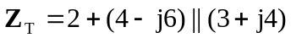
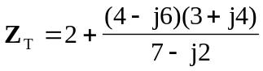
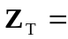 6.83 + j1.094  = 6.9179.1 

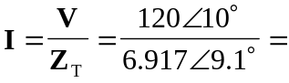 17.350.9 A

